CHAPTER 2
Human Reproduction
• Human Reproduction

2.0 | Reproductive Events in Humans

As you are aware, humans are sexually reproducing and viviparous. Human reproduction runs through a fixed series of events, each with its own name.
1 | Gametogenesis - the formation of gametes: sperms in males and ovum in females.
2 | Insemination - the transfer of sperms into the female genital tract.
3 | Fertilisation - the fusion of male and female gametes, leading to formation of the zygote.
4 | Formation and development of the blastocyst and its attachment to the uterine wall (implantation).
5 | Gestation - the embryonic development inside the uterus.
6 | Parturition - the delivery of the baby.

All these reproductive events occur only after puberty. There is an important difference between the sexes in how long gamete formation lasts: sperm formation continues even in old men, but formation of ovum ceases in women around the age of fifty years.
2.1 | The Male Reproductive System

The male reproductive system is located in the pelvis region. It includes a pair of testes along with accessory ducts, glands and the external genitalia.
2.1a | The Testes

The testes are situated outside the abdominal cavity within a pouch called the scrotum. The scrotum maintains the low temperature of the testes - 2-2.5°C lower than the normal internal body temperature - which is necessary for spermatogenesis.
In adults, each testis is oval, with a length of about 4 to 5 cm and a width of about 2 to 3 cm. The testis is covered by a dense covering. Each testis has about 250 compartments called testicular lobules, and each lobule contains one to three highly coiled seminiferous tubules in which sperms are produced.
Each seminiferous tubule is lined on its inside by two types of cells: the male germ cells (spermatogonia) and the Sertoli cells. The male germ cells undergo meiotic divisions, finally leading to sperm formation, while the Sertoli cells provide nutrition to the germ cells.
The regions outside the seminiferous tubules, called interstitial spaces, contain small blood vessels and interstitial cells, also called Leydig cells. The Leydig cells synthesise and secrete testicular hormones called androgens. Other immunologically competent cells are also present.
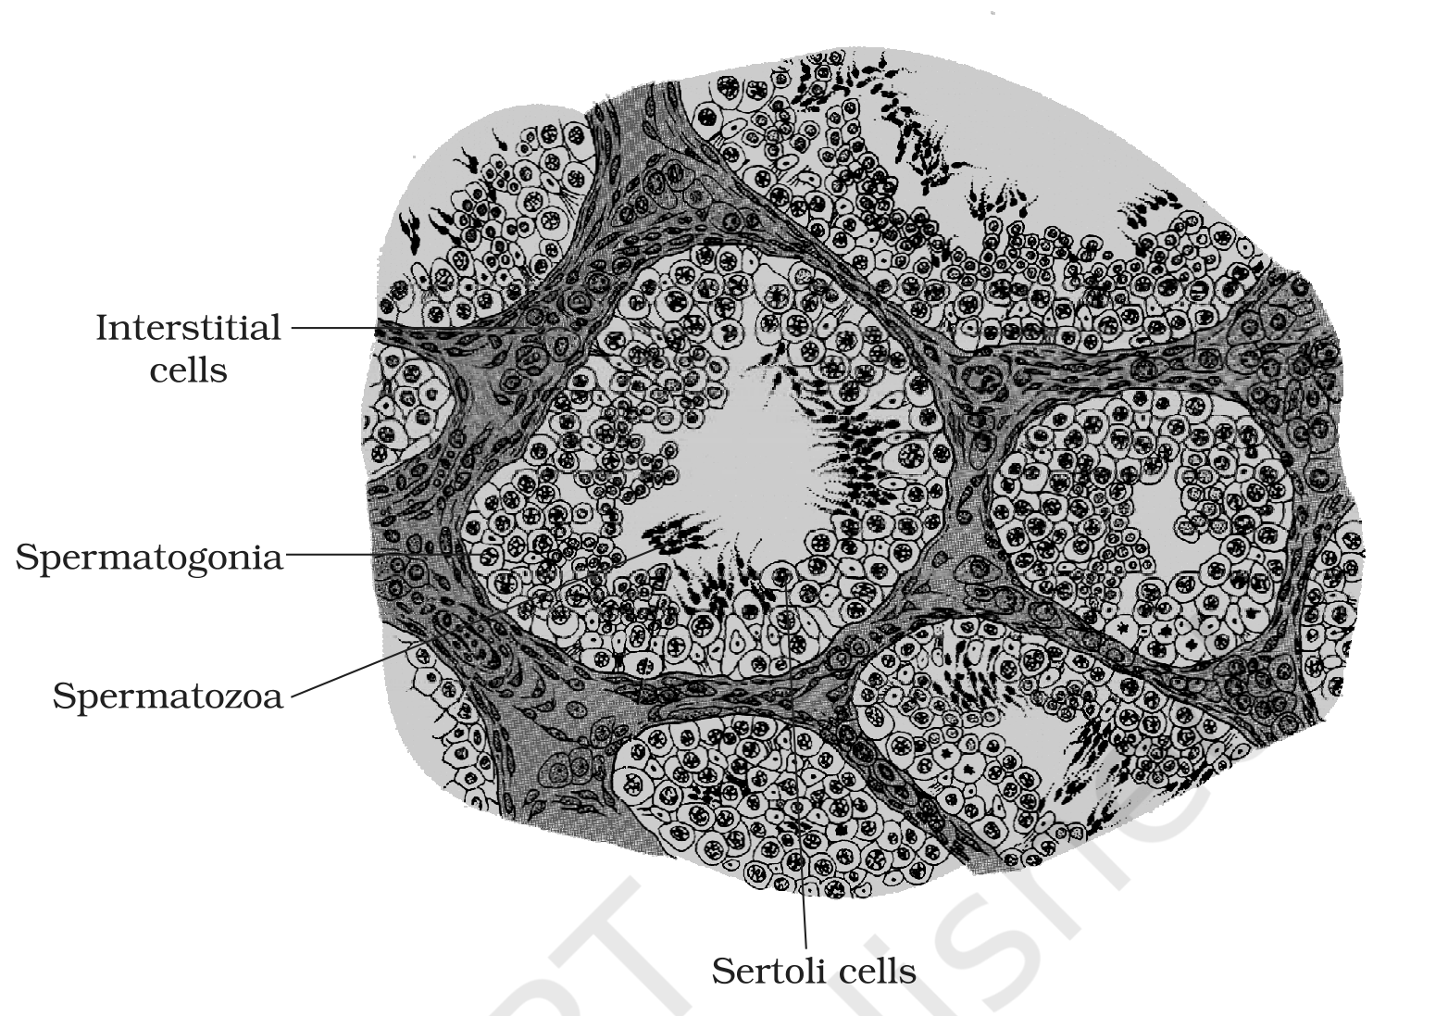
Fig. 2.2 - Diagrammatic sectional view of a seminiferous tubule. Labelled parts: interstitial cells, spermatogonia, spermatozoa and Sertoli cells.
2.1b | Accessory Ducts, Penis and Glands

The male sex accessory ducts include the rete testis, vasa efferentia, epididymis and vas deferens. Their connected path carries the sperms outward:
1 | The seminiferous tubules of the testis open into the vasa efferentia through the rete testis.
2 | The vasa efferentia leave the testis and open into the epididymis, located along the posterior surface of each testis.
3 | The epididymis leads to the vas deferens, which ascends to the abdomen and loops over the urinary bladder.
4 | The vas deferens receives a duct from the seminal vesicle and opens into the urethra as the ejaculatory duct.
5 | The urethra originates from the urinary bladder and extends through the penis to its external opening called the urethral meatus.

Together, these ducts store and transport the sperms from the testis to the outside through the urethra.
The penis is the male external genitalia. It is made up of a special tissue that helps in erection of the penis to facilitate insemination. The enlarged end of the penis, called the glans penis, is covered by a loose fold of skin called the foreskin.
The male accessory glands include the paired seminal vesicles, a prostate and the paired bulbourethral glands. The secretions of these glands constitute the seminal plasma, which is rich in fructose, calcium and certain enzymes. The secretions of the bulbourethral glands also help in the lubrication of the penis.
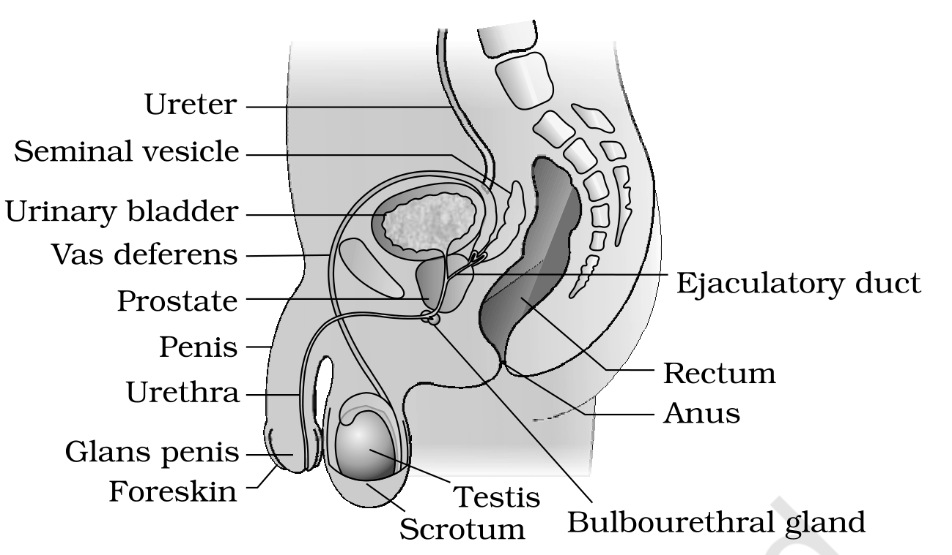
Fig. 2.1a - Diagrammatic sectional view of the male pelvis showing the reproductive system. Labelled parts: ureter, urinary bladder, seminal vesicle, ejaculatory duct, prostate, bulbourethral gland, vas deferens, urethra, penis, glans penis, foreskin, testis, scrotum, rectum and anus.
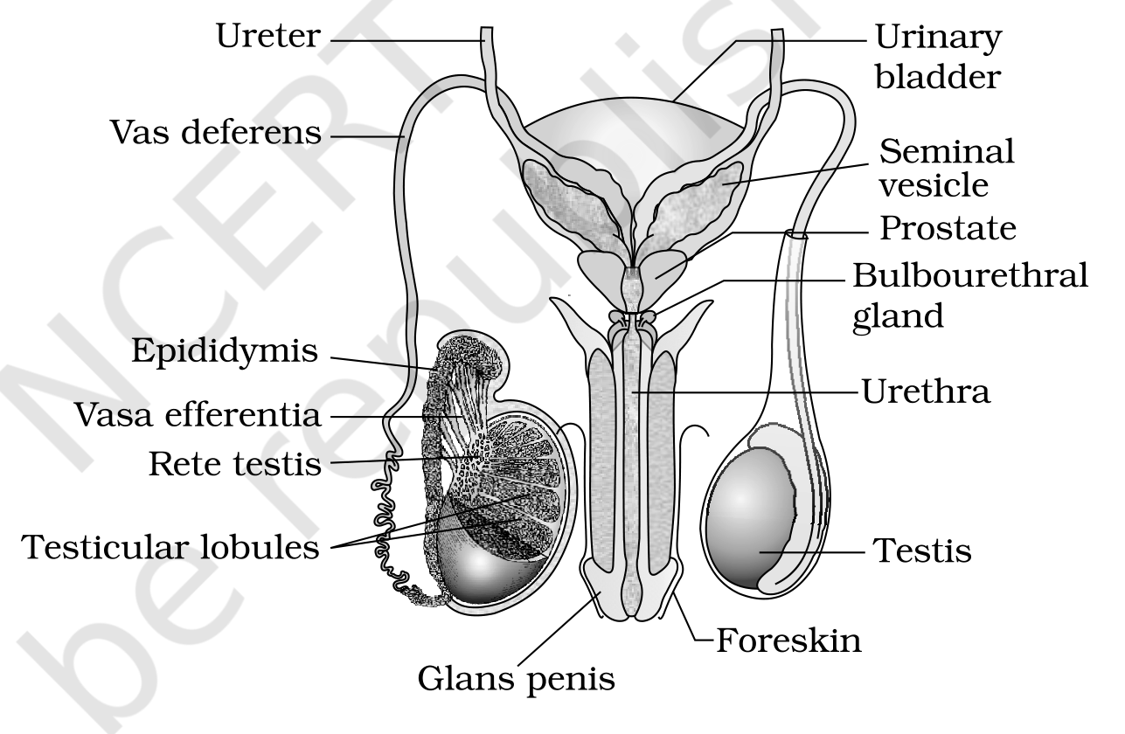
Fig. 2.1b - Diagrammatic view of the male reproductive system (part of the testis is opened to show inner details). Labelled parts: ureter, urinary bladder, seminal vesicle, prostate, bulbourethral gland, vas deferens, epididymis, vasa efferentia, rete testis, testicular lobules, urethra, glans penis, foreskin and testis.
2.2 | The Female Reproductive System

The female reproductive system consists of a pair of ovaries along with a pair of oviducts, a uterus, a cervix, a vagina and the external genitalia, located in the pelvic region. These parts, along with a pair of mammary glands, are integrated structurally and functionally to support ovulation, fertilisation, pregnancy, birth and child care.
2.2a | The Ovaries

The ovaries are the primary female sex organs that produce the female gamete (ovum) and several steroid hormones (ovarian hormones). They are located one on each side of the lower abdomen. Each ovary is about 2 to 4 cm in length and is connected to the pelvic wall and uterus by ligaments.
Each ovary is covered by a thin epithelium which encloses the ovarian stroma. The stroma is divided into two zones - a peripheral cortex and an inner medulla. Ovarian follicles in different stages of development are embedded in the stroma.
2.2b | The Accessory Ducts - Oviducts, Uterus, Cervix, Vagina

The oviducts (fallopian tubes), uterus and vagina constitute the female accessory ducts. Each fallopian tube is about 10-12 cm long and extends from the periphery of each ovary to the uterus. Its parts, from the ovary towards the uterus, are:
1 | Infundibulum - the funnel-shaped part closer to the ovary. Its edges have finger-like projections called fimbriae, which help in the collection of the ovum after ovulation.
2 | Ampulla - the wider part of the oviduct that the infundibulum leads into.
3 | Isthmus - the last part of the oviduct, which has a narrow lumen and joins the uterus.

The uterus is single and is also called the womb. Its shape is like an inverted pear, and it is supported by ligaments attached to the pelvic wall. The uterus opens into the vagina through a narrow cervix. The cavity of the cervix is called the cervical canal, which along with the vagina forms the birth canal.
The wall of the uterus has three layers of tissue:
Layer | Position | Nature / feature
Perimetrium | External | Thin membranous layer
Myometrium | Middle | Thick layer of smooth muscle; exhibits strong contraction during delivery of the baby
Endometrium | Inner | Glandular layer that lines the uterine cavity and undergoes cyclical changes during the menstrual cycle

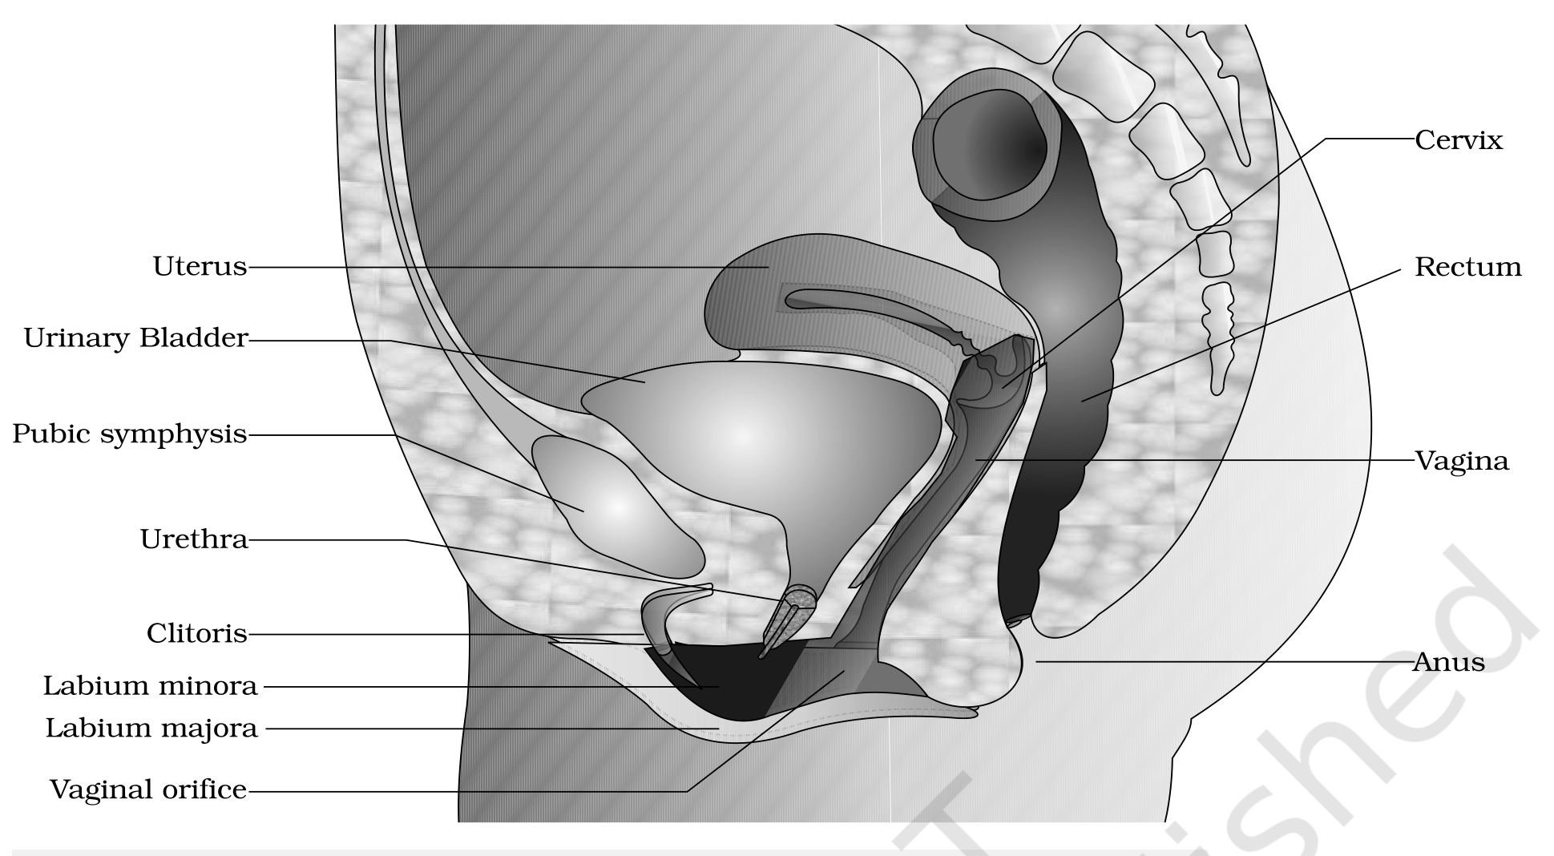
Fig. 2.3a - Diagrammatic sectional view of the female pelvis showing the reproductive system. Labelled parts: uterus, urinary bladder, pubic symphysis, urethra, clitoris, labium minora, labium majora, vaginal orifice, cervix, rectum, vagina and anus.
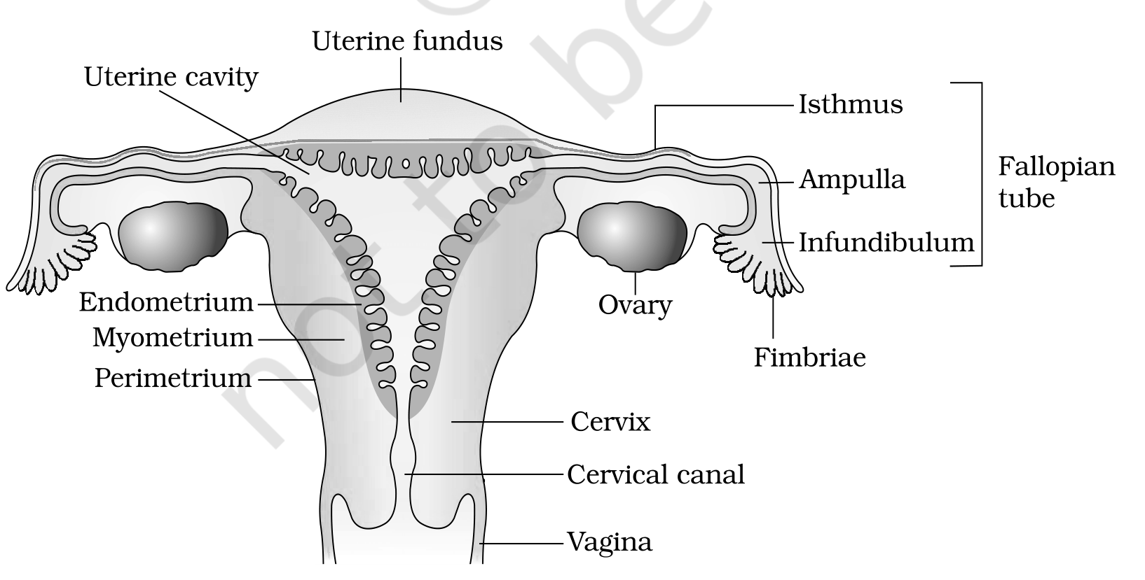
Fig. 2.3b - Diagrammatic sectional view of the female reproductive system. Labelled parts: uterine fundus, uterine cavity, endometrium, myometrium, perimetrium, isthmus, ampulla, infundibulum, fallopian tube, ovary, fimbriae, cervix, cervical canal and vagina.
2.2c | The External Genitalia

The female external genitalia include the mons pubis, labia majora, labia minora, hymen and clitoris.
• Mons pubis - a cushion of fatty tissue covered by skin and pubic hair.
• Labia majora - fleshy folds of tissue which extend down from the mons pubis and surround the vaginal opening.
• Labia minora - paired folds of tissue under the labia majora.
• Hymen - a membrane that often partially covers the opening of the vagina.
• Clitoris - a tiny finger-like structure which lies at the upper junction of the two labia minora above the urethral opening.
[NOTE] The hymen is often torn during the first coitus (intercourse). It can also be broken by a sudden fall or jolt, insertion of a vaginal tampon, or active participation in some sports like horseback riding, cycling, etc. In some women the hymen persists even after coitus. Therefore the presence or absence of the hymen is not a reliable indicator of virginity or sexual experience.

2.2d | The Mammary Glands

A functional mammary gland is characteristic of all female mammals, and the mammary glands are one of the female secondary sexual characteristics. The mammary glands are paired structures (breasts) that contain glandular tissue and a variable amount of fat. Milk drains from the gland along a fixed path:
1 | The glandular tissue of each breast is divided into 15-20 mammary lobes containing clusters of cells called alveoli.
2 | The cells of the alveoli secrete milk, which is stored in the cavities (lumens) of the alveoli.
3 | The alveoli open into mammary tubules.
4 | The tubules of each lobe join to form a mammary duct.
5 | Several mammary ducts join to form a wider mammary ampulla, which is connected to a lactiferous duct and opens at the nipple, from where milk is expressed during breastfeeding.

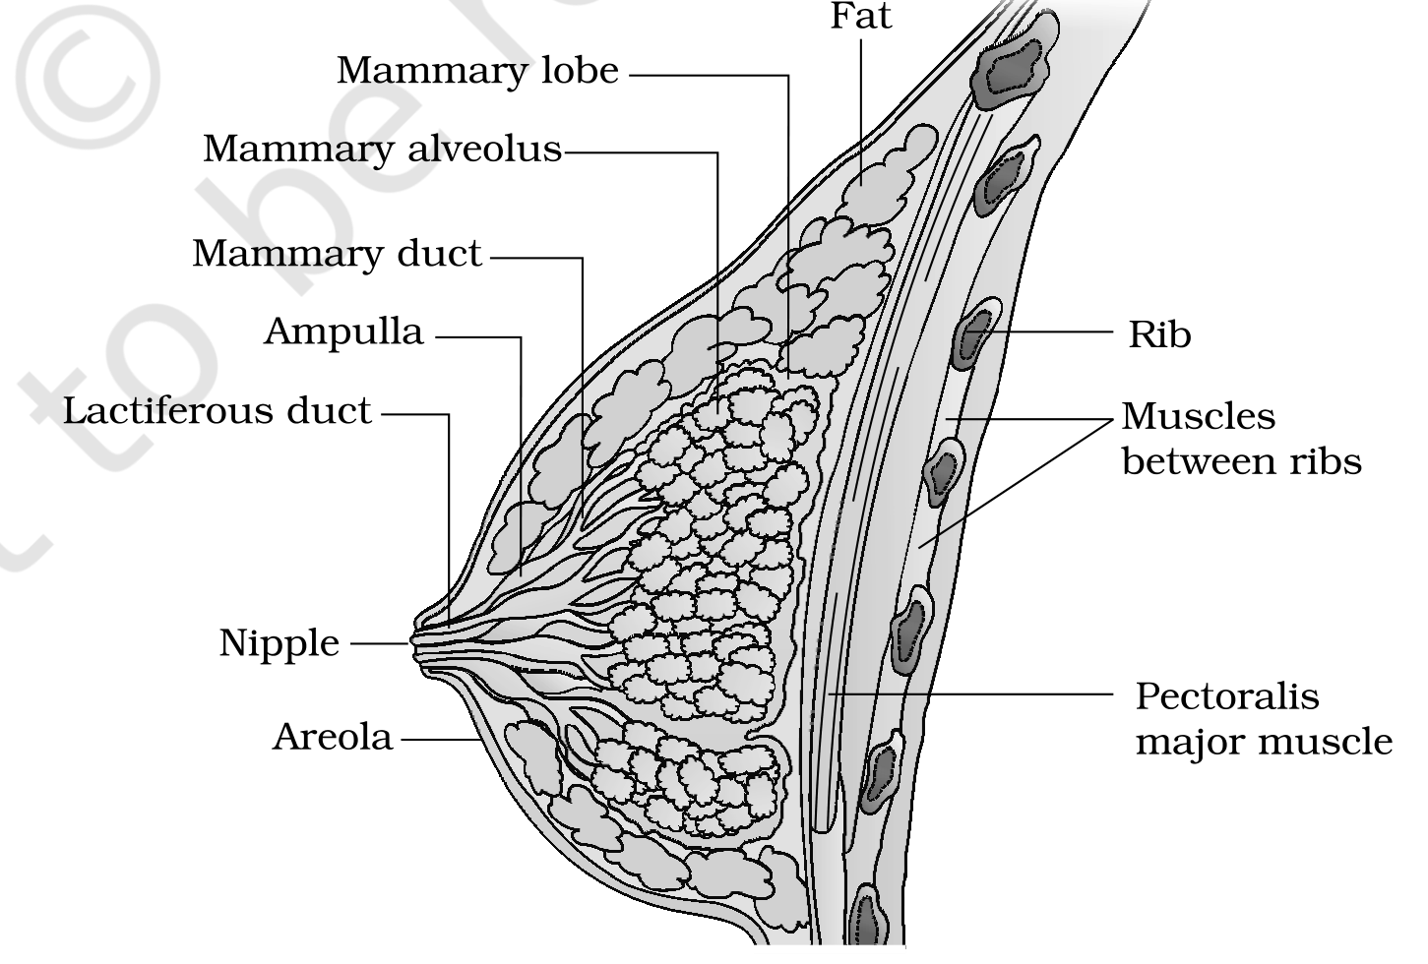
Fig. 2.4 - A diagrammatic sectional view of a mammary gland. Labelled parts: mammary lobe, mammary alveolus, mammary duct, ampulla, lactiferous duct, nipple, areola, fat, rib, muscles between ribs and pectoralis major muscle.
2.3 | Gametogenesis

The primary sex organs - the testis in males and the ovaries in females - produce gametes, i.e. sperms and ovum respectively, by the process called gametogenesis.
2.3a | Spermatogenesis

In the testis, immature male germ cells (spermatogonia) produce sperms by spermatogenesis, a process that begins at puberty. The steps are:
1 | Spermatogonia (sing. spermatogonium) on the inside wall of the seminiferous tubules multiply by mitotic division and increase in number. Each spermatogonium is diploid and contains 46 chromosomes.
2 | Some spermatogonia, called primary spermatocytes, periodically undergo meiosis.
3 | A primary spermatocyte completes the first meiotic division (reduction division), producing two equal, haploid secondary spermatocytes, each with only 23 chromosomes.
4 | The secondary spermatocytes undergo the second meiotic division to produce four equal, haploid spermatids.
5 | The spermatids are transformed into spermatozoa (sperms) by the process called spermiogenesis.
6 | After spermiogenesis, the sperm heads become embedded in the Sertoli cells and are finally released from the seminiferous tubules by the process called spermiation.

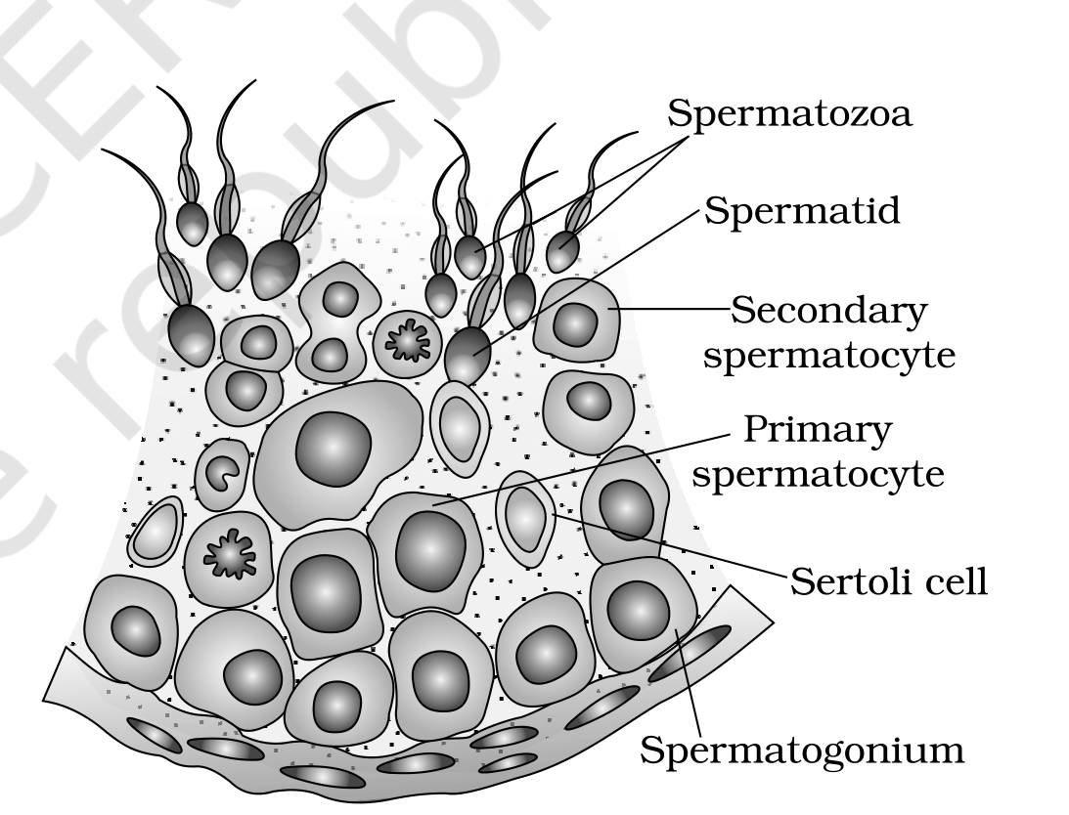
Fig. 2.5 - Diagrammatic sectional view of a seminiferous tubule (enlarged). Labelled cells: spermatogonium, primary spermatocyte, secondary spermatocyte, spermatid, spermatozoa and Sertoli cell.
2.3b | Hormonal Control of Spermatogenesis

Spermatogenesis starts at puberty due to a significant increase in the secretion of gonadotropin releasing hormone (GnRH), which is a hypothalamic hormone.
1 | Increased GnRH acts at the anterior pituitary gland and stimulates secretion of two gonadotropins - luteinising hormone (LH) and follicle stimulating hormone (FSH).
2 | LH acts at the Leydig cells and stimulates synthesis and secretion of androgens. The androgens, in turn, stimulate the process of spermatogenesis.
3 | FSH acts on the Sertoli cells and stimulates secretion of some factors which help in the process of spermiogenesis.

2.3c | Structure of the Sperm

A sperm is a microscopic structure composed of a head, a neck, a middle piece and a tail. A plasma membrane envelops the whole body of the sperm.
• Head: contains an elongated haploid nucleus, the anterior portion of which is covered by a cap-like structure, the acrosome. The acrosome is filled with enzymes that help fertilisation of the ovum.
• Middle piece: possesses numerous mitochondria, which produce energy for the movement of the tail that facilitates sperm motility essential for fertilisation.
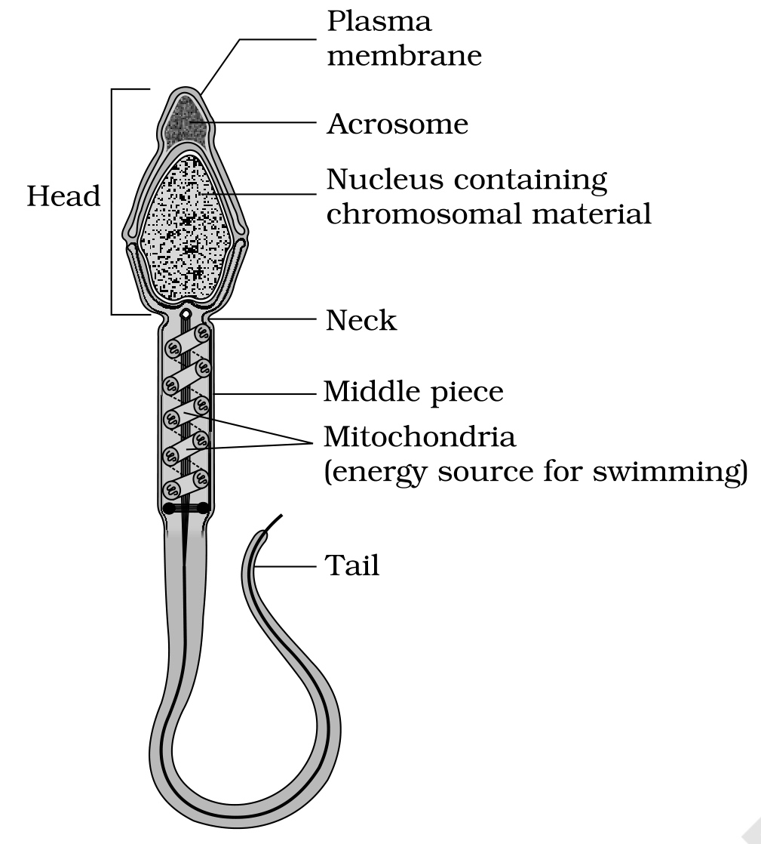
Fig. 2.6 - Structure of a sperm. Labelled parts: plasma membrane, acrosome, nucleus, head, neck, middle piece, mitochondria and tail.
The human male ejaculates about 200 to 300 million sperms during a coitus. For normal fertility, at least 60 per cent of sperms must have normal shape and size and at least 40 per cent must show vigorous motility.
Sperms released from the seminiferous tubules are transported by the accessory ducts. The secretions of the epididymis, vas deferens, seminal vesicle and prostate are essential for the maturation and motility of sperms. The seminal plasma along with the sperms constitutes the semen. The functions of the male sex accessory ducts and glands are maintained by the testicular hormones (androgens).
2.3d | Oogenesis

Oogenesis - the formation of a mature female gamete - is markedly different from spermatogenesis. It is initiated during the embryonic development stage, when a couple of million gamete mother cells (oogonia) are formed within each fetal ovary. No more oogonia are formed and added after birth.
1 | Oogonia start division and enter prophase-I of the meiotic division, then get temporarily arrested at that stage; they are now called primary oocytes.
2 | Each primary oocyte gets surrounded by a layer of granulosa cells and is called a primary follicle. A large number of these follicles degenerate during the phase from birth to puberty, so that at puberty only 60,000-80,000 primary follicles are left in each ovary.
3 | The primary follicles get surrounded by more layers of granulosa cells and a new theca and are called secondary follicles.
4 | A secondary follicle transforms into a tertiary follicle, characterised by a fluid-filled cavity called the antrum. The theca layer is organised into an inner theca interna and an outer theca externa.
5 | At the tertiary-follicle stage the primary oocyte grows in size and completes its first meiotic division. This is an unequal division, resulting in a large haploid secondary oocyte and a tiny first polar body; the secondary oocyte retains the bulk of the nutrient-rich cytoplasm of the primary oocyte.
6 | The tertiary follicle further changes into the mature follicle or Graafian follicle. The secondary oocyte forms a new membrane called the zona pellucida surrounding it.
7 | The Graafian follicle ruptures to release the secondary oocyte (ovum) from the ovary by the process called ovulation.

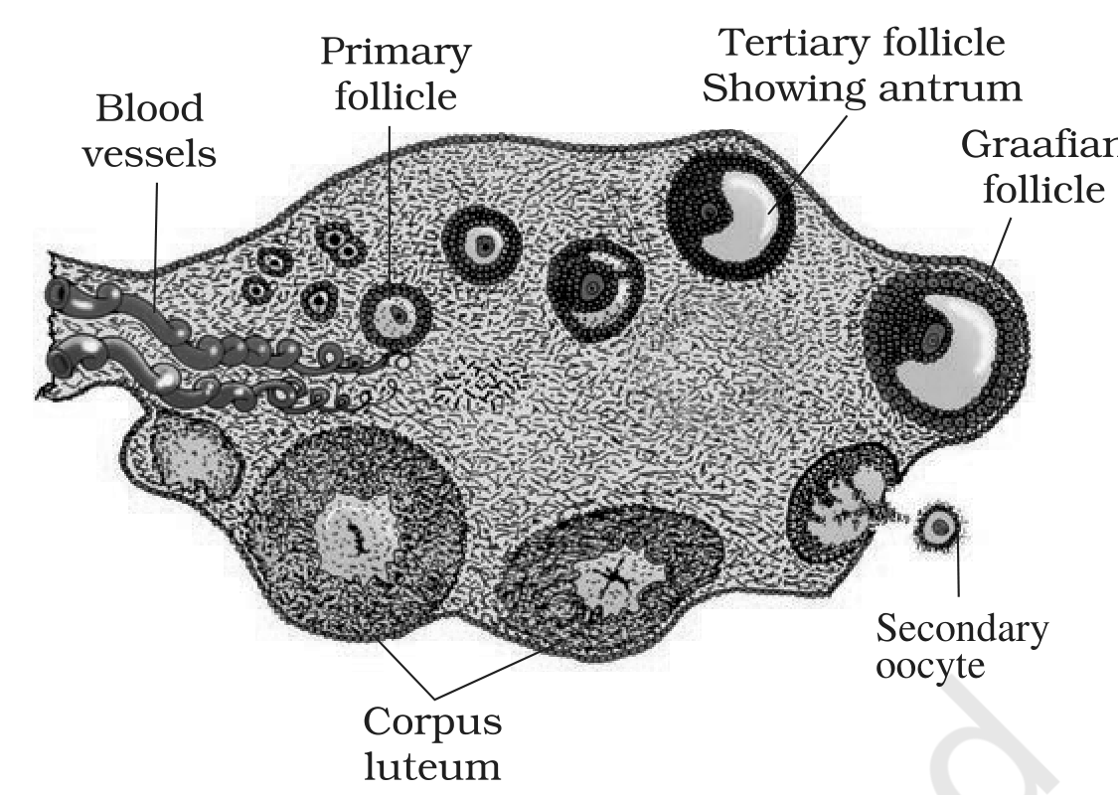
Fig. 2.7 - Diagrammatic sectional view of an ovary. Labelled parts: blood vessels, primary follicle, tertiary follicle, antrum, Graafian follicle, secondary oocyte and corpus luteum.
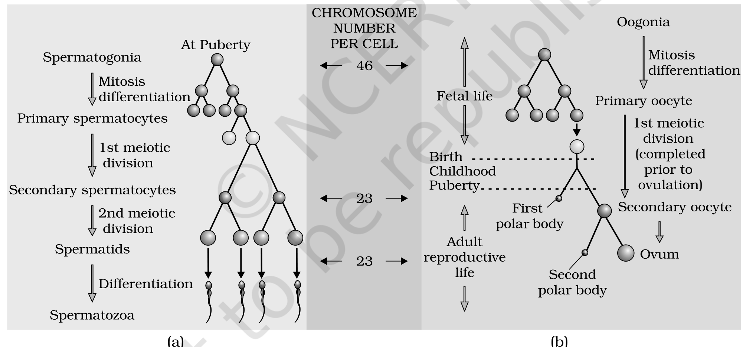
Fig. 2.8 - Schematic representation of (a) spermatogenesis and (b) oogenesis. Labelled: spermatogonia, mitosis, primary spermatocytes, secondary spermatocytes, spermatids and spermatozoa, with the chromosome number per cell shown as 46 and 23; and oogonia, primary oocyte, secondary oocyte, first polar body, second polar body and ovum.
2.4 | Menstrual Cycle

The reproductive cycle in the female primates (e.g. monkeys, apes and human beings) is called the menstrual cycle. The first menstruation begins at puberty and is called menarche.
In human females, menstruation is repeated at an average interval of about 28/29 days. The cycle of events starting from one menstruation till the next is called the menstrual cycle, and one ovum is released (ovulation) during the middle of each menstrual cycle.
The cycle proceeds through the following phases:
1 | Menstrual phase: the cycle starts with the menstrual phase, when menstrual flow occurs; it lasts for 3-5 days. The menstrual flow results due to breakdown of the endometrial lining of the uterus and its blood vessels, which forms a liquid that comes out through the vagina.
2 | Follicular phase: the primary follicles grow to become a fully mature Graafian follicle and, simultaneously, the endometrium regenerates through proliferation.
3 | Ovulatory phase: the LH surge induces rupture of the Graafian follicle and release of the ovum (ovulation).
4 | Luteal phase: the remaining parts of the Graafian follicle transform into the corpus luteum, which secretes large amounts of progesterone.

[NOTE] Menstruation only occurs if the released ovum is not fertilised. A lack of menstruation may be indicative of pregnancy; it may also be caused due to some other underlying causes like stress, poor health, etc.

These changes in the ovary and the uterus are induced by changes in the levels of pituitary and ovarian hormones. The secretion of gonadotropins (LH and FSH) increases gradually during the follicular phase and stimulates follicular development as well as the secretion of estrogens by the growing follicles. Both LH and FSH attain a peak level in the middle of the cycle (about the 14th day). The rapid secretion of LH leading to its maximum level during mid-cycle, called the LH surge, induces rupture of the Graafian follicle and release of the ovum (ovulation).
The progesterone secreted by the corpus luteum is essential for maintenance of the endometrium. Such an endometrium is necessary for implantation of the fertilised ovum and other events of pregnancy. During pregnancy all events of the menstrual cycle stop and there is no menstruation. In the absence of fertilisation, the corpus luteum degenerates, causing disintegration of the endometrium leading to menstruation, which marks a new cycle.
In human beings, menstrual cycles cease around 50 years of age; that is termed menopause. Cyclic menstruation is an indicator of a normal reproductive phase and extends between menarche and menopause.
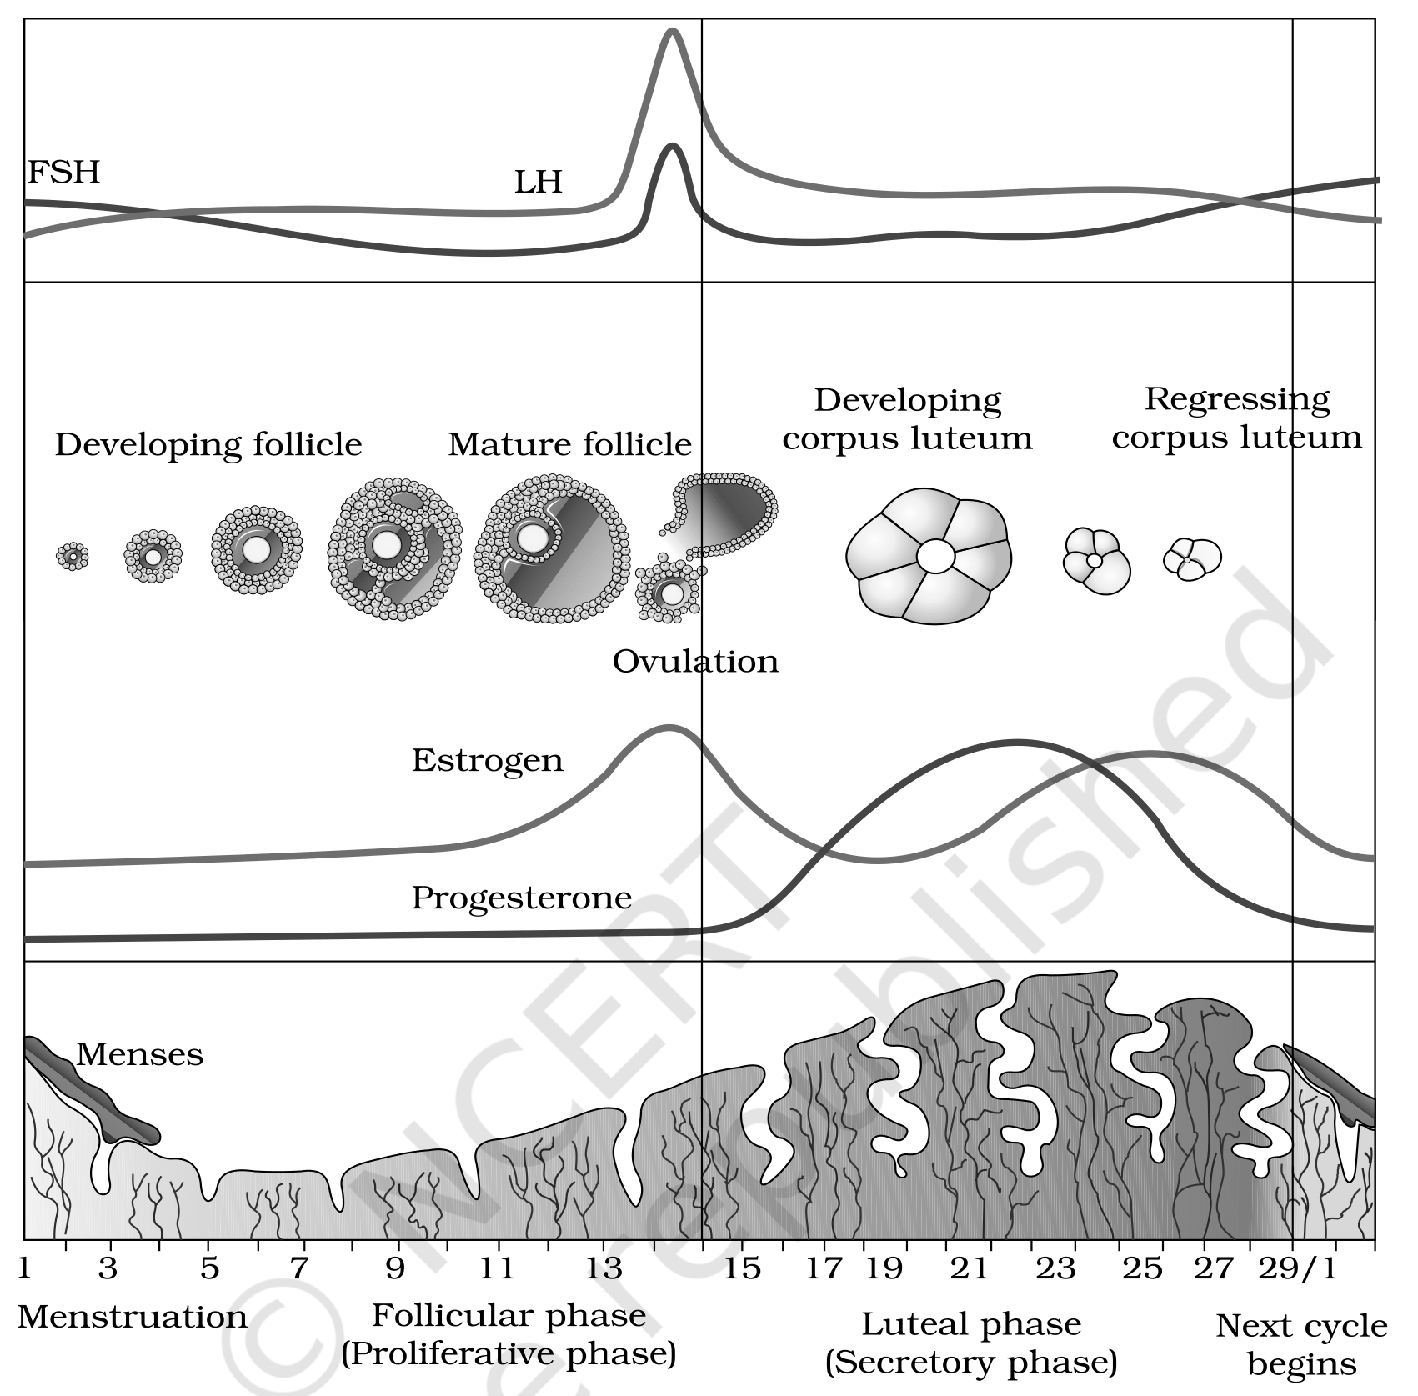
Fig. 2.9 - Diagrammatic presentation of the various events during a menstrual cycle. Labelled: FSH, LH, developing follicle, mature follicle, corpus luteum, ovulation, estrogen, progesterone, menses, the follicular phase and the luteal phase.
[NOTE] Menstrual Hygiene. Maintenance of hygiene and sanitation during menstruation is very important. Take a bath and clean regularly; use sanitary napkins or clean homemade pads; change them after every 4-5 hrs as per requirement; dispose of used napkins by wrapping them in used paper; do not throw used napkins in the drainpipe of toilets or in the open area; and after handling the napkin, wash hands with soap.

2.5 | Fertilisation and Implantation

During copulation (coitus), semen is released by the penis into the vagina (insemination). The motile sperms swim rapidly, pass through the cervix, enter the uterus and finally reach the ampullary region of the fallopian tube. The ovum released by the ovary is also transported to the ampullary region, where fertilisation takes place.
[NOTE] Fertilisation can only occur if the ovum and sperms are transported simultaneously to the ampullary region. This is why not all copulations lead to fertilisation and pregnancy.

2.5a | Fertilisation

The process of fusion of a sperm with an ovum is called fertilisation. During fertilisation, a sperm comes in contact with the zona pellucida layer of the ovum and induces changes in the membrane that block the entry of additional sperms. This ensures that only one sperm can fertilise an ovum. The secretions of the acrosome help the sperm enter the cytoplasm of the ovum through the zona pellucida and the plasma membrane.
This entry induces completion of the meiotic division of the secondary oocyte. The second meiotic division is also unequal and results in a second polar body and a haploid ovum (ootid). The haploid nucleus of the sperm and that of the ovum fuse together to form a diploid zygote.
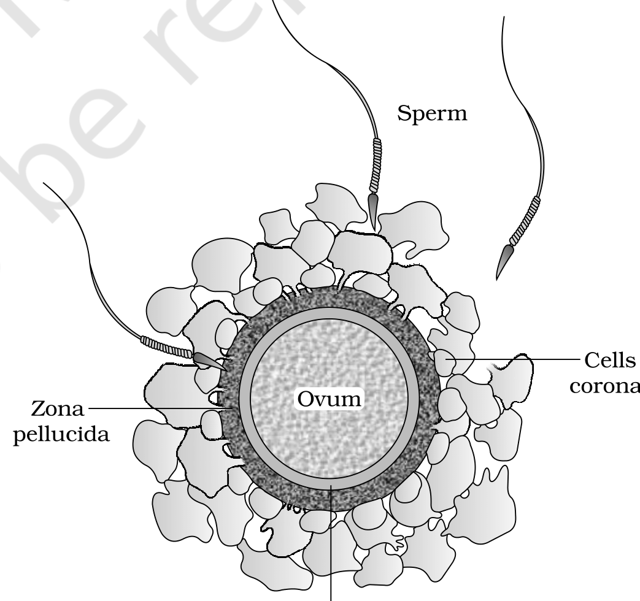
Fig. 2.10 - Ovum surrounded by a few sperms. Labelled parts: sperm, zona pellucida, corona radiata, perivitelline space and ovum.
2.5b | Sex Determination

The sex of the baby is decided at the fertilisation stage. The chromosome pattern in the human female is XX and in the male is XY. All haploid gametes (ova) produced by the female have the sex chromosome X, whereas in male gametes (sperms) the sex chromosome could be either X or Y - 50 per cent of sperms carry X and the other 50 per cent carry Y.
Thus the zygote carries either XX or XY depending on whether the X- or Y-bearing sperm fertilised the ovum: XX develops into a female baby and XY into a male (more on chromosomal patterns in Chapter 5). Therefore, scientifically it is correct to say that the sex of the baby is determined by the father and not by the mother.
2.5c | Cleavage and Implantation

1 | Mitotic division called cleavage starts as the zygote moves through the isthmus of the oviduct towards the uterus and forms 2, 4, 8, 16 daughter cells called blastomeres.
2 | The embryo with 8 to 16 blastomeres is called a morula.
3 | The morula continues to divide and transforms into a blastocyst as it moves further into the uterus. The blastomeres in the blastocyst are arranged into an outer layer called the trophoblast and an inner group of cells attached to the trophoblast called the inner cell mass.
4 | The trophoblast layer gets attached to the endometrium and the inner cell mass gets differentiated as the embryo.
5 | After attachment, the uterine cells divide rapidly and cover the blastocyst, so the blastocyst becomes embedded in the endometrium - this is called implantation, and it leads to pregnancy.

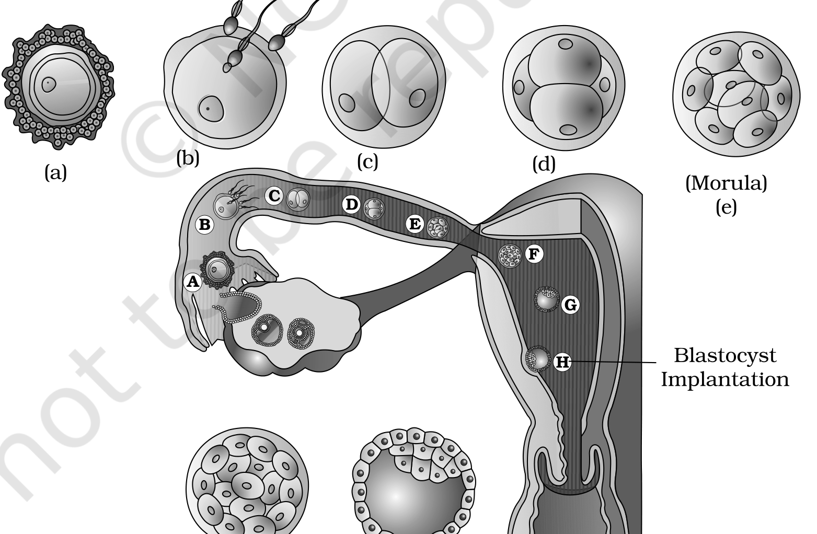
Fig. 2.11 - Transport of the ovum, fertilisation, and passage of the growing embryo through the fallopian tube. Labelled stages: morula, blastocyst and implantation.
2.6 | Pregnancy and Embryonic Development

After implantation, finger-like projections appear on the trophoblast called chorionic villi, which are surrounded by the uterine tissue and maternal blood. The chorionic villi and uterine tissue become interdigitated and jointly form a structural and functional unit between the developing embryo (foetus) and the maternal body called the placenta.
The placenta facilitates the supply of oxygen and nutrients to the embryo and the removal of carbon dioxide and excretory/waste materials produced by the embryo. It is connected to the embryo through an umbilical cord, which helps in the transport of substances to and from the embryo.
The placenta also acts as an endocrine tissue and produces hormones like human chorionic gonadotropin (hCG), human placental lactogen (hPL), estrogens, progestogens, etc. In the later phase of pregnancy, a hormone called relaxin is also secreted by the ovary.
[NOTE] hCG, hPL and relaxin are produced in women only during pregnancy. In addition, during pregnancy the levels of other hormones like estrogens, progestogens, cortisol, prolactin, thyroxine, etc. are increased several-fold in the maternal blood. The increased production of these hormones is essential for supporting fetal growth, metabolic changes in the mother, and maintenance of pregnancy.

Immediately after implantation, the inner cell mass (embryo) differentiates into an outer layer, the ectoderm, and an inner layer, the endoderm; a mesoderm soon appears between them. These three (germ) layers give rise to all tissues (organs) in adults. The inner cell mass contains certain cells called stem cells which have the potency to give rise to all the tissues and organs.
Human pregnancy lasts 9 months. The growth of the foetus follows a recognisable timeline:
Stage of pregnancy | Development observed
After 1 month | The embryo's heart is formed; the first sign of the growing foetus may be noticed by listening to the heart sound through a stethoscope.
End of 2 months | The foetus develops limbs and digits.
End of 12 weeks (first trimester) | Most major organ systems are formed; the limbs and external genital organs are well-developed.
Fifth month | The first movements of the foetus and the appearance of hair on the head are usually observed.
End of about 24 weeks (end of second trimester) | The body is covered with fine hair, the eye-lids separate, and eyelashes are formed.
End of 9 months | The foetus is fully developed and ready for delivery.

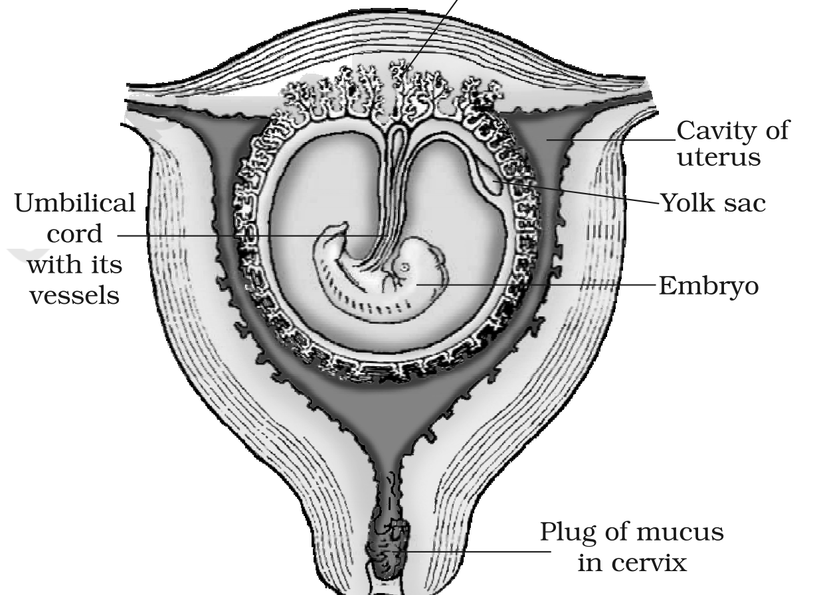
Fig. 2.12 - The human foetus within the uterus. Labelled parts: placental villi, umbilical cord, cavity of uterus, yolk sac, embryo and cervix.
2.7 | Parturition and Lactation

The average duration of human pregnancy is about 9 months, which is called the gestation period. Vigorous contraction of the uterus at the end of pregnancy causes expulsion/delivery of the foetus. The process of delivery of the foetus (childbirth) is called parturition.
Parturition is induced by a complex neuroendocrine mechanism involving cortisol, estrogens and oxytocin. It proceeds as a self-reinforcing reflex:
1 | Signals for parturition originate from the fully developed foetus and the placenta and induce mild uterine contractions called the foetal ejection reflex.
2 | The foetal ejection reflex triggers the release of oxytocin from the maternal pituitary.
3 | Oxytocin acts on the uterine muscle and causes stronger uterine contractions, which in turn stimulate further secretion of oxytocin.
4 | This stimulatory reflex between uterine contraction and oxytocin secretion continues, resulting in stronger contractions and expulsion of the baby through the birth canal (parturition).

Soon after the infant is delivered, the placenta is also expelled out of the uterus.
The mammary glands undergo differentiation during pregnancy and start producing milk towards the end of pregnancy by the process called lactation. Lactation helps the mother in feeding the new-born. The milk produced during the initial few days of lactation is called colostrum, which contains several antibodies absolutely essential to develop resistance for the new-born babies. Hence breast-feeding during the initial period of infant growth is recommended by doctors for bringing up a healthy baby.
QR | Quick Recap

• Humans are sexually reproducing and viviparous. The male reproductive system is a pair of testes, the male sex accessory ducts, accessory glands and external genitalia.
• Each testis has about 250 testicular lobules, each with one to three seminiferous tubules lined by spermatogonia (which undergo meiosis to form sperms) and Sertoli cells (which nourish the germ cells); the Leydig cells outside the tubules secrete androgens. The male external genitalia is the penis.
• The female reproductive system is a pair of ovaries, a pair of oviducts, a uterus, a vagina, external genitalia and a pair of mammary glands. The ovaries produce the ovum and ovarian (steroid) hormones, with ovarian follicles at different stages embedded in the stroma. The uterus has three layers - perimetrium, myometrium and endometrium, and the mammary glands are a female secondary sexual characteristic.
• Spermatogenesis yields sperms carried by the accessory ducts; a sperm has a head, neck, middle piece and tail. Oogenesis forms the mature female gamete. The reproductive cycle of female primates is the menstrual cycle, which starts only after puberty, releases one ovum per cycle, and is controlled by pituitary and ovarian hormones.
• After coitus, sperms reach the ampulla, where a sperm fertilises the ovum to form a diploid zygote; the X- or Y-bearing sperm determines the sex. The zygote forms a blastocyst that is implanted in the uterus, the placenta connects foetus and mother, and gestation lasts about 9 months.
• Parturition is induced by a complex neuroendocrine mechanism involving cortisol, estrogens and oxytocin; the mammary glands secrete milk (lactation) after childbirth, beginning with the antibody-rich colostrum.
EX | Terms Used in the Exercises

Two exercise questions rely on ideas the chapter itself does not spell out. Both are answered here using only chapter-based reasoning.
• Identical vs fraternal twins. The chapter states that one ovum is normally released per menstrual cycle and that a single sperm fertilises a single ovum to form one zygote. Identical twins arise when one fertilised ovum (one zygote) splits to give two embryos - they share the same genetic make-up. Fraternal (non-identical) twins arise when two separate ova are released and fertilised by two separate sperms, giving two genetically different embryos.
• Eggs released for a litter of six puppies. Because each puppy develops from its own fertilised ovum (one zygote per offspring), a dog delivering a litter of six puppies must have released at least six ova in that cycle, each fertilised by a separate sperm.
Every fact, number, name, qualifier, table row, figure and figure label in NCERT Class 12 Chapter 2 is carried above. Nothing outside the source chapter has been added, except the clearly marked NOTE/MEMORY AID material and the exercise-gap explanations, which are derived only from chapter content.

